**PROJECT-2**

**DEPLOY WORDPRESS MANUALLY IN AWS.**

**Task-1:** Create IAM user

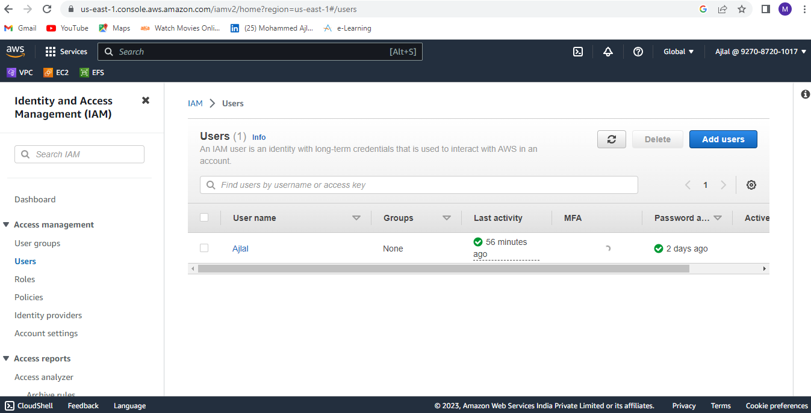

**Task-2:** Create a custom vpc. Create a internet gateway and attach to vpc.

* Public and private subnet, public route table and private route table. Attach subnets to route tables.
* Create a Nat gateway and attach to private route table to allow internet access to private instance.

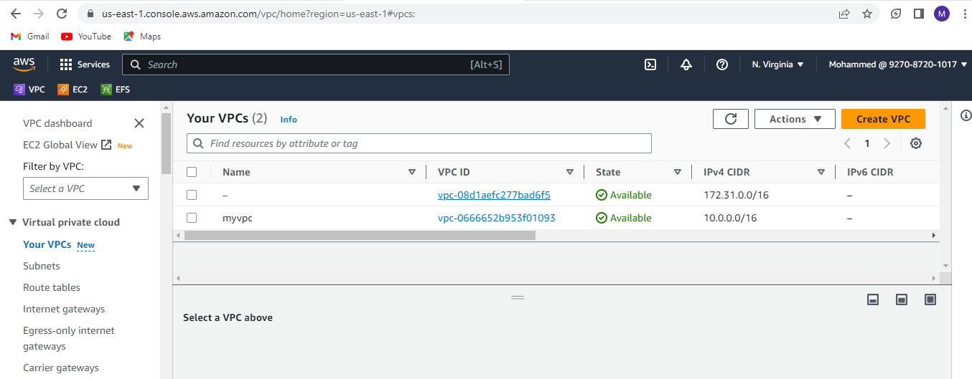

**Task-3:** Connect to public instance.

* Connect private instance with public instance by copying pem file into public

instance.

Command: scp -i .\mykey. pem .\mykey.pem ec2-user@public Ip:~

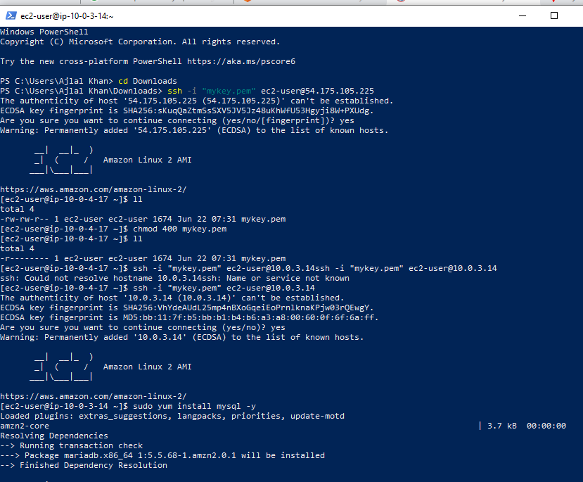

**Task-4:** Create MySQL database in AWS console by providing required configuration.

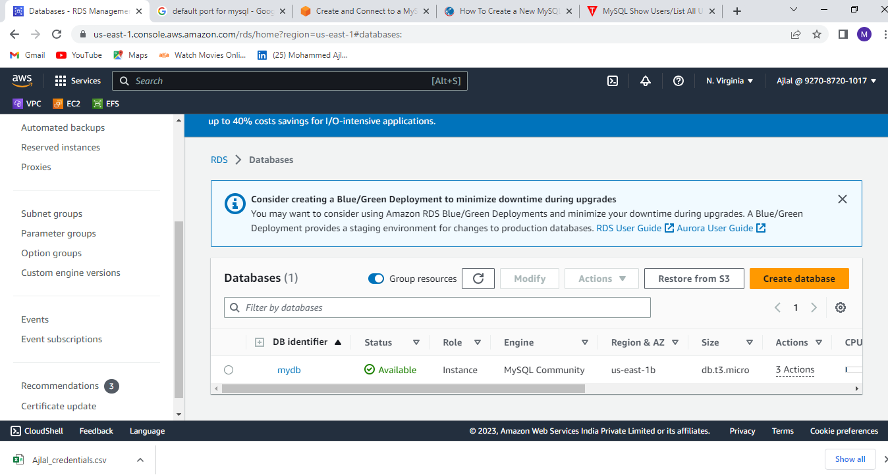

**Task-5:** Install MySQL in private instance and connect MySQL with database which is created in AWS.

Command to connect MySQL with database: MySQL -h <endpoint of db> -u <username> -p

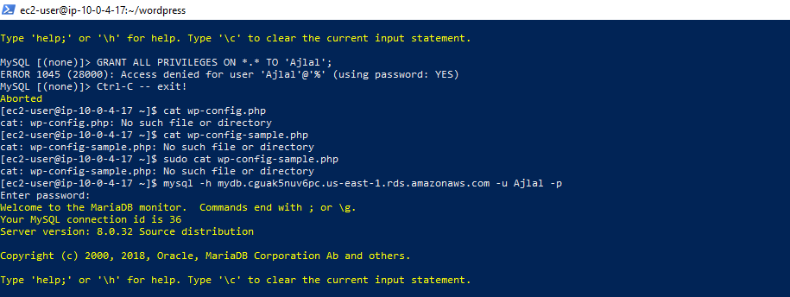

**Task-6:** Create a new SQL user with below command.

Command: CREATE USER 'username' IDENTIFIED BY 'password'; (give username and password)

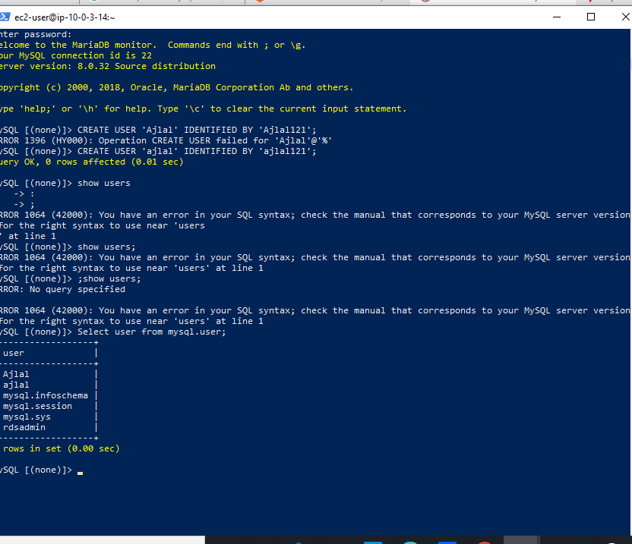

**Task-7:** Grant all privileges to newly created MySQL user.

Command: GRANT ALL PRIVILEGES ON database_name.* TO 'database_user';

**Task-8:** Check MYSQL user by executing command “SELECT user FROM mysql.user “

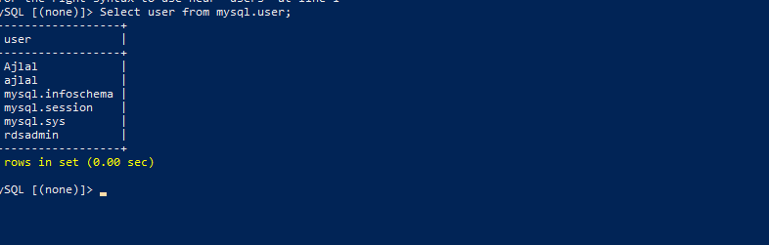

**Task-9:** Exit from MYSQL and private instance.

**Task-10:** Install wordpress in public instance.

Command: sudo wget <https://wordpress.ord/latest.zip>

* After installing wordpress a zip file will be downloaded with name latest.zip
* Unzip file by executing command “unzip latest.zip”

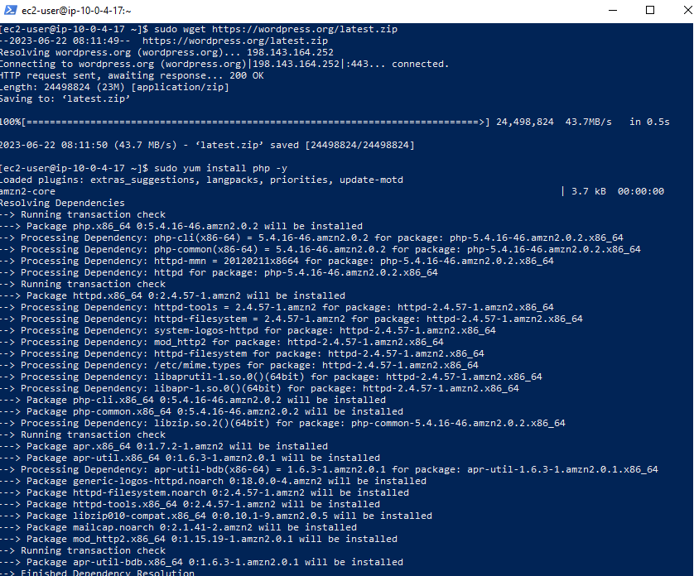

**Task-11:** Copy wp-config-sample.php file with name wp-config.php

Command: cp wp-config-sample.php wp-config.php

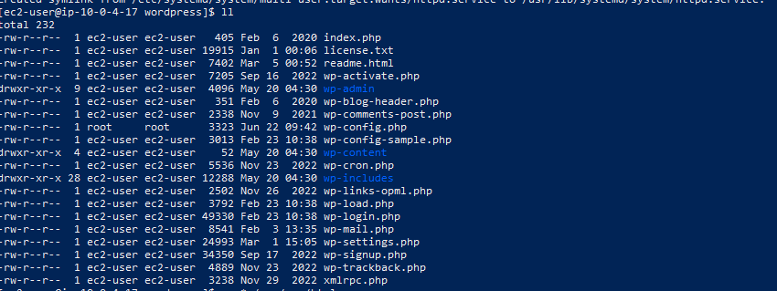

**Task-12:** Add keys and Database configurations in wp-config.php file by executing vi command.

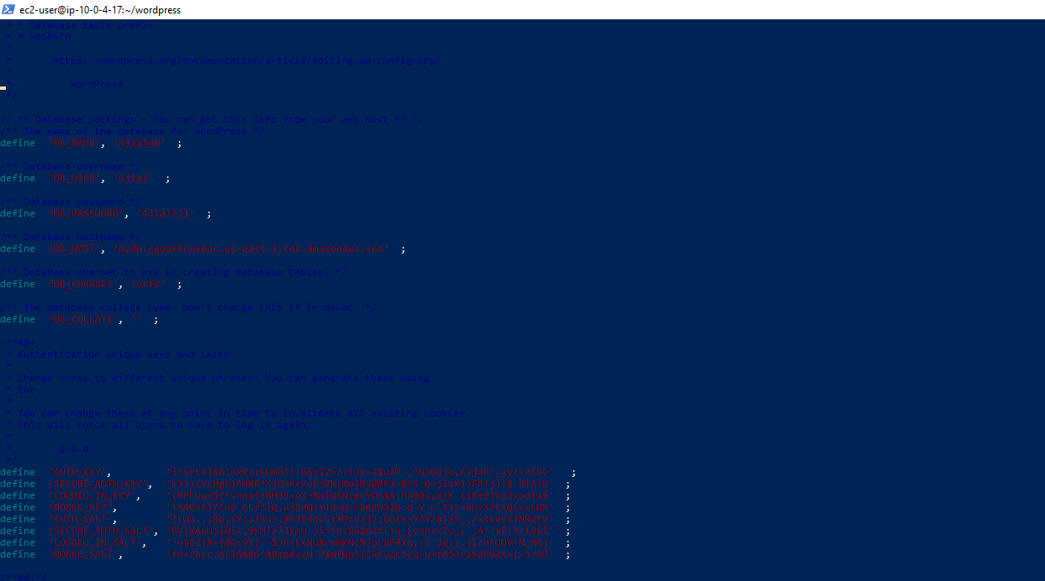

**Task-13:** Install mysql in public instance

Command: sudo yum install mysql -y

**Task-14:** Install php and php-mysql in public instance.

Command: sudo amazon-linux-extras install -y lamp-mariadb10.2-php7.2 php7.2

* Sudo yum install php-mysql -y

**Task-15:** Install httpd in public instance.

Command: sudo yum install httpd -y

* Sudo systemctl start httpd
* Sudo systemctl enable httpd

**Task-16:** Copy all wordpress file in httpd default directory.

Restart httpd server by executing sudo systemctl restart httpd.

**Task-17:** Browse with public ip of public instance to see wordpress page.

